

JIRA Work Flow

JIRA URL: https://id.atlassian.com

**JIRA is a workflow management system for tracking issues under the project created**

JIRA Login Page

* Log in to JIRA
* Click the **Log In** Button once enter the **Username** and **Password**.

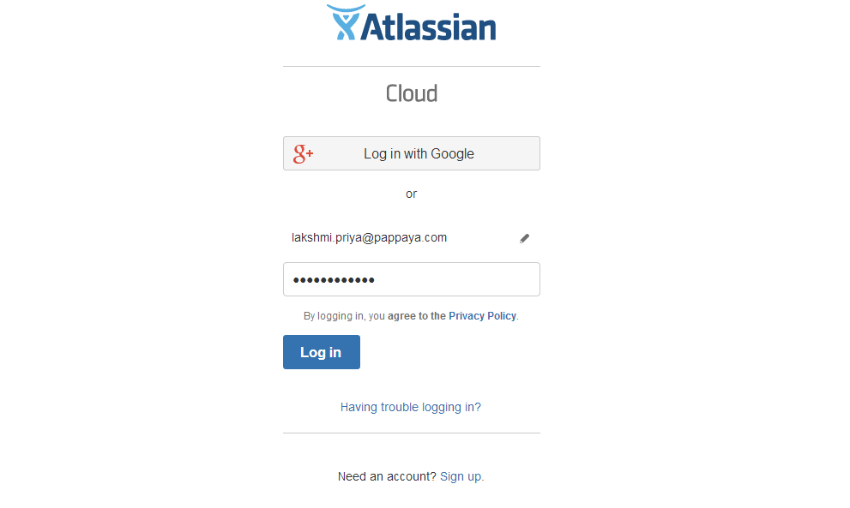

This is the first page in this screenshot we see after logging in to JIRA

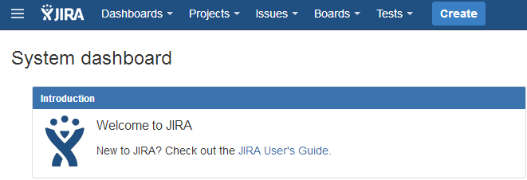

**JIRA User's Guide**

1. **Dashboards**

* View System Dashboard
* Manage Dashboards: This page allows you to manage all dashboards you own.

1. **Projects**

* PRMS Live Observations (PLO)
* Pappaya Sales & Helpdesk (PSH)
* Pappaya - Build Deployment (PBD)
* Pappaya Testing (PT)
* Software
* Business

1. **Issues**

* Current Search
* Search for issues
* Import issues from CSV
* My Open issues
* Reported by me
* Manage Filters

1. **Boards**

* Defects
* PSH board
* View all boards

1. **Tests**

This tab is Zephyr - Test Management for JIRA used mostly by development team to create or carry out tests and maintain a log of it effectively in JIRA.

Example 1:

SDS Client raised an issue that **"they are not receiving most of the emails and emails are getting bounced".**

When we received a call from SDS client for the above issue, created a JIRA ticket under relevant project [**For this project selected** **PRMS Live Observation (PLO)**] and assigned the ticket to the concern person on the L2 Team.

## The following points shown that how to create a new JIRA Ticket on the above client issue:

* Click '**Create' button** at the top of the screen to open the **Create Issue**
* Select the relevant**'**[**Project**](https://confluence.atlassian.com/jira064/what-is-a-project-720416135.html)**'** and '[**Issue Type**](https://confluence.atlassian.com/jira064/what-is-an-issue-720416138.html#WhatisanIssue-IssueType)' on the **Create Issue**

**Project**

What are the Project & Type?

* PRMS Live Observations (PLO)
* Pappaya Sales & Helpdesk (PSH)
* Pappaya - Build Deployment (PBD)
* Pappaya Testing (PT)

**Issue Type**

* **Task**: Task that needs to be done.
* **Bug**: Problem that impairs product or service functionality.
* **New Feature**: Adding new features of the tool as per the client's request
* **Improvement**: To modify or improve an already existing feature of the tool
* **Epic**: An epic can span more than one project. For example, performance-related work in a release
* **Story:** Functionality request expressed from the perspective of the user.
* Type a summary for the issue, write a complete description and fill the appropriate fields as needed
* To Attach Files or Screenshot to an issue, click **Browse** to search the files and attached to the issue.
* Once the new JIRA ticket is raised under issue and it should be Assigned to the concern person on the team.
* Select the Priority field based on the issue type
* Highest
* High
* Medium
* Low
* Lowest
* Labels: Tagging a name of the Clients
* The Assignee need to check and change the status in to next stage as any of the below if need to investigate more on the issue,

Type of STATUS

* **In Progress**:

Once the Developer picks the Task, it will be moved to the stage **'In Progress'**

* **Ready for Deployment**:

After the code is fixed, the stages of the issue have been changed to **'Ready for Deployment'**

* **In Test**:

After the Deployment, it will be moved to the stage **'In Test'**

* **Under Review**:

Once the testing is done, it will be moved to the stage **'Under Review'**. (If the test is failed, the ticket will be moved to the stage 'In Progress’ for the review)

* **Rejected:**

After going through all the stages, Approver may reject the ticket for any valid reason and it will have moved to the stage '**Rejected'**

* **Cancelled**:

If the ticket is invalid and not a bug, Assignee stop the progress and change the stages in to '**Cancelled'**

* **Approved:**

When the issue is resolved, Assignee will be close the ticket by clicking the stages 'Done' is known as **'Approved'.**

One issue has been created for the client as shown in the below screenshot.

Eg: Created one Issue

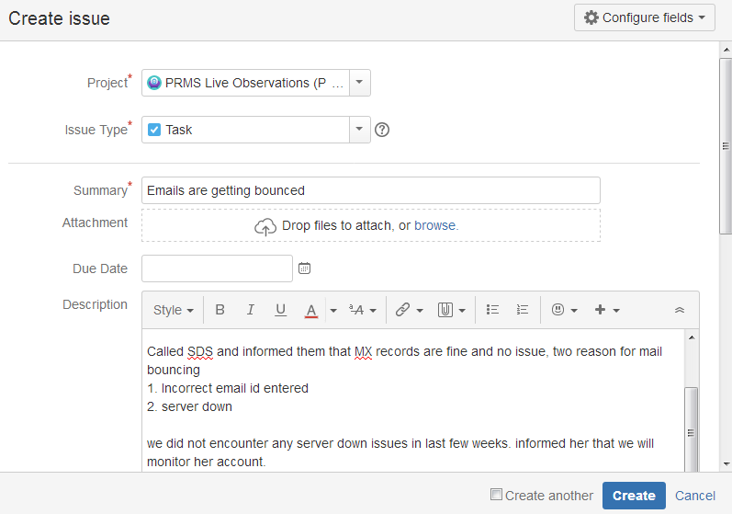

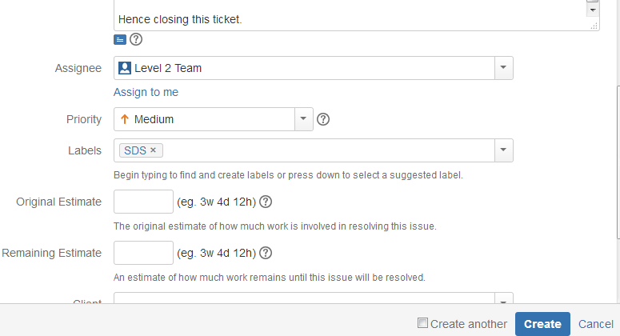

JIRA Ticket Workflow

